Welcome to the team! Read this sheet IMMEDIATELY to get started!
Work Weeks
Full-time counselors need to check off the weeks that they can work. You are
committing to those weeks. Part-time substitutes will be called, as needed. We
can’t make any promises, but if you check a certain week, make sure you are
available that week, as we often have walk-up registrations, counselors who fall
ill and other unforeseen reasons to call.
Cell Phones & Social Media
There is absolutely no cell phones usage allowed during camp hours (this
includes training sessions). Leave your cell phones at home, or if you chose to
bring it along, there will be a collection box in which you can keep it during
camp hours, stored inside of the Carriage House. If you need to make a call
during work, feel free to use the Carriage House phone. As stated in our Staff
Manual, cell phone possession and usage results in dismissal from one’s position.
Only senior staff members will carry cell phones for internal communication
reasons only.
Your social media is a representation of you and our Day Camp. Check your
Twitter, Instagram, YouTube, Facebook, Vine, etc. for appropriate material.
You’re in the work force and you are an extension of the place for which you
work. Parents of campers may Google counselors working with their children to
check his/her social media to learn about the persons interacting with their
child. In short, clean up your social media accounts. We are checking too. Sorry,
it’s the way of the world now. Besides our Day Camp family, future employers,
colleges, university, etc. will view what you post.
Paperwork (visit http://www.mendhamdaycamp.com/welcome-to-our-team.html for fillable documents)
We provide an entire month to complete all of the necessary paperwork. Please
complete it ASAP.
•All employees must fill out a 2021 W-4 tax form. Do not use nicknames on this
form, use your legal birth name. Please write your date of birth on the
bottom of the sheet for our record.
•All employees must fill out a MEDICAL RELEASE/WAIVER and allergy action plan,
if applicable. Visit the webpage, type in your responses, print it, sign it
(with a parent, if applicable), and hand it in with your paperwork.
•All employees must read through the Staff Manual, print and sign the last page,
documenting that they have read and understand their job
responsibilities.

•All employees must ensure they have followed applicable guidelines for
performing a Background Check.
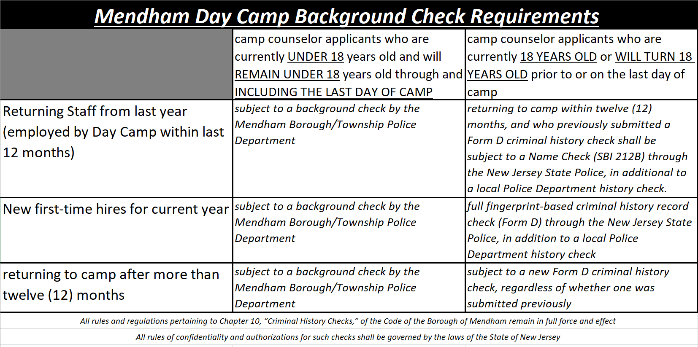
•If you were born after June 6, 2003, you must fill out Working Papers and have a
Background Check completed by your local Police Department. Working
papers are available at your current school. If you are currently in 8th grade,
you must complete your paperwork with the aid of Mt. View or St. Joseph's,
etc. Only current 9th graders and up should go to their high school
for paperwork completion. In hopes of easing the process, please see the
step-by-step instructions. For info: http://lwd.dol.state.nj.us/labor/forms_pdfs/
lsse/mw-373.pdf
•If you born before June 6, 2003, you must complete a criminal-history
Background Check.
We WILL NOT accept paperwork at the training session on June 6, 2021. We
expect all paperwork returned to the Recreation Offices (6 West Main Street) by
Friday, June 4th at 4pm. No exceptions will be made. Late or incomplete
paperwork may jeopardize employment.

Sign Up
Make sure you sign up for Remind! This will be our number one form of
communication this summer. This is how we will send out staff assignments -
either Friday night or Saturday - and any other pertinent information. It is your
responsibility to find out if you are working. We will expect to see you, if you are
on the list.
Salary
Everyone’s favorite subject! As per our postings, there is a new pay scale.
The good news…you will be paid for your training session, provided that all of
your paperwork (above) is complete on time!
Checklist to complete BEFORE June 4, 2021:
_______ Complete your contract - check off weeks (write them down
somewhere, so you remember) and sign it
_______ Clean up social media accounts
_______ Fill out W-4 write birthday between this on the bottom of the form:
(Cat. No. 10220Q Form W-4 (2021))
_______ Complete your medical release form and any necessary allergy action
plan
_______ Read entire staff manual, print the last page, and sign it
_______ Complete the process for working papers, if applicable
_____ Complete steps for background check
_______ Provide a copy of your COVID-19 Vaccination Card if you have it
_______ Sign up for Remind to receive text alerts regarding work
_______ Submit to Bruce at the Bower’s Building NO LATER than Friday, June 4,
2021 at 4pm, the following: completed contract, W-4, medical release
(and allergy action plan, if necessary), last page of the staff manual -
signed (by signing it, you are stating that you have read and are willing
to abide by the standards and expectations put in place for your
employment), working papers, if applicable, receipt of background
check, copy of vaccination card

